Z Test
Statement:
A panel randomly sampled 25 subjects from an honours program. We want to determine whether their mean IQ score, 107 differs from the general population. The general population’s IQ scores are defined as having a mean of 100 and a standard deviation of 15.
So, we need to check whether the mean IQ Score of the sampled subjects is significantly different from the population mean of 100.
Let us use a two-tailed analysis with a significance level of 0.05
Null Hypothesis: (H₀): µ = 100
Alternative (H_{A}): µ ≠ 100
IQ score sample mean (x̅): 107
Sample size (n): 25
Hypothesized population mean (µ₀): 100
Population standard deviation (σ): 15
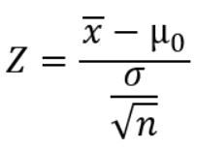
Zcalculated=(107-100)/(15/√25)=2.33
So Zvalue = (1 + 0.95)/2 = 0.975
Therefore, Z(actual) =1.960 (after referring the 0.975 in the Z Table)
Since, Zcalculated > Zactual
We reject the Null Hypothesis
Statistically, the mean of the samples IQ score are significantly different from the general population.

